
FT/FMAK/1223/A 14-JUN-2023
FIRST TERM EXAMINATION ( 2023-24 )
Subject: FMM (Answer key)  Grade: 12 | Max. Marks: 60  Time: 3 hrs
Name: |  | Section: | Roll No:
General Instructions:
- Please read the instructions carefully.
- This Question Paper consists of 24 questions in two sections – Section A & Section B.
- Section A has Objective type questions whereas Section B contains Subjective type questions.
- Out of the given (6 + 18 =) 24 questions, a candidate has to answer (6 + 11 =) 17 questions in the allotted (maximum) time of 3 hours.
- All questions of a particular section must be attempted in the correct order.
- SECTION A - OBJECTIVE TYPE QUESTIONS (30 MARKS):
  - This section has 06 questions.
  - There is no negative marking.
  - Do as per the instructions given.
  - Marks allotted are mentioned against each question/part.
- SECTION B – SUBJECTIVE TYPE QUESTIONS (30 MARKS):
  - This section contains 18 questions.
  - A candidate has to do 11 questions.
  - Do as per the instructions given.
  - Marks allotted are mentioned against each question/part.

SECTION A: OBJECTIVE TYPE QUESTIONS

Q 1 | Answer any 4 out of the given 6 questions on Employability Skills (1 x 4 = 4 marks)
i) | . Intrinsic Motivation | 1
ii) | b. Narcissistic personality disorder | 1
iii) | Interpersonal skills are the behaviors and tactics a person uses to interact with others effectively. | 1
iv) | b. Knowing your relatives | 1
v) | d)all the above
vi) | d)All of the above.
Q. 2 | Answer any 5 out of the given 7 questions (1 x 5 = 5 marks)
i) | Net worth is the value of all assets, minus the total of all liabilities. | 1
ii) | (b) 24 hours | 1
iii) | Dematerialization, or DEMAT, is the transition away from paper certificates to a form of electronic record for stock transactions. | 1
iv) | (a) Is also known as the old issues market. | 1
v) | (c) Opening a trading account and Demat account, Placing an order, Execution of order, Settlement of order | 1
vi) | d. Provides access to trading platform of a stock exchange as an agent of the stock broker. | 1
vii) | Unique Client Code is an identification number for clients which the brokers have to mandatorily maintain. | 1
Q. 3 | Answer any 6 out of the given 7 questions (1 x 6 = 6 marks)
i) | b. The order is cancelled | 1
ii) | - Square off | 1
iii) | It is the price at which the exchange servers will make you Buy/Sell order active for execution | 1
iv) | All of the above. | 1
v) | c.Snap quote | 1
vi) | The Market Movement screen provides information to the user regarding the movement of a security for the current day. | 1
vii) | d.None of the above | 1
Q. 4 | Answer any 5 out of the given 6 questions (1 x 5 = 5 marks)
i) | The protection of investors;2 • Ensuring that markets are fair, efficient and transparent; The reduction of systemic risk. | 1
ii) | - Turnover ratio | 1
iii) | NSCCL | 1
iv) | d)All of the above | 1
v) | c)Lowest, Highest | 1
vi) | 2.5% | 1
Q. 5 | Answer any 5 out of the given 6 questions (1 x 5 = 5 marks)
i) | A very small aperture terminal (VSAT) is a small-sized earth station used in the transmit/receive of data, | 1
ii) | The default password consists of the last six digits of your Neat Device's serial number | 1
iii) | By default, the Excel Quick Access Toolbar contains only 3 buttons: Save, Undo and Redo. | 1
iv) | d.All of the above | 1
v) | Wireless Application Protocol | 1
vi | d)Professional Clearing Member | 1
Q. 6 | Answer any 5 out of the given 6 questions (1 x 5 = 5 marks)
i) | Any person or persons holding 51% on his/ their own or together with the entities as specified. below will be identified as Dominant Promoter Group. | 1
ii) | One of the objectives of setting up SEBI was to protect the interests of investors. | 1
iii) | b.Misconduct | 1
iv) | - Order Routing System | 1
v) | A security descriptor contains the security information associated with a securable object. | 1
vi | passive order is a trading order in which the order price is different from the market price.  An order is called active when it's running either for the duration of the trading day or for the duration of the trading day plus extended trading hours. | 1

 | SECTION B: SUBJECTIVE TYPE QUESTIONS
 | Answer any 3 out of the given 5 questions in 20 – 30 words each (2 x 3 = 6 marks)
Q. 7 | - Embrace Your Strengths.  - Adapt to Challenges.  - Nurture Your Relationships With Others.  - Set Goals for Yourself.  - Understand Your Emotions.  - Be Patient. | 2
Q. 8 | Extraversion, Agreeableness, Conscientiousness, Neuroticism, and Openness to Experience. | 2
Q. 9 | the person carries out all entrepreneurial activities as inherited in the same manner or introduces certain technological advancements to the existing way and method of the family business. | 2
Q. 10 | startups can be started with minimum investment. Most startups thrive on an idea that involve technology or offer technology driven solutions. For example, a lot of startups have started online food delivery. With the help of a robust app, they partner with food service providers or restaurants, and help in the home delivery of food. | 2
Q. 11 | Entrepreneurship competencies combine creativity, a sense of initiative, problem-solving, the ability to marshal resources, and financial and technological knowledge. These competencies enable entrepreneurs and entrepreneurial employees to provoke and adapt to change | 2
 | Answer any 3 out of the given 5 questions in 20 – 30 words each (2 x 3 = 6 marks)
Q. 12 | - Business in Securities in which Dealings not Permitted: If it enters into dealings in securities in which dealings are not permitted  - Business for Defaulting Constituent: If it deals or transacts business directly or indirectly or executes an order for a constituent who has within its knowledge failed to carry out engagements relating to securities and is in default to another Trading Member, unless such constituent shall have made a satisfactory arrangement with the Trading Member who is its creditor  - Business for Insolvent: If without first obtaining the consent of the relevant authority, it directly or indirectly is interested in or associated in business with or transacts any business with or for any individual who has been bankrupt or insolvent even though such individual shall have obtained his final discharge from an Insolvency Court  - Business without Permission when under Suspension | 2
Q. 13 | An outstanding order is an order that has been entered by the user, but which has not yet been completely traded or cancelled. The user is permitted to see his orders. | 2
Q. 14 | 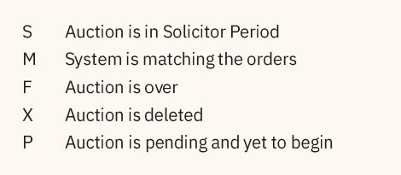 | 2
Q. 15 | Temporary Sign Off: Temporary sign off is a useful feature that allows the user to disallow the use of the trading software without actually logging off. During a temporary sign-off period, the application continues to receive all market updates in the background.. If three attempts are made to sign on with an incorrect password, the user is permanently logged off. In this case the user has to log on again. | 2
Q. 16 | The online market information displayed in the market watch screen is for current best price orders available in the Regular Lot book. For each security the following information is displayed: a) The corporate action indicator “Ex/Cum” b) The total buy order quantity available at best buy price c) Best buy price d) Best sell price e) Total sell order quantity available at best sell price f) The last traded price g) The last trade price change indicator and h) The no delivery period indicator “ND” | 2
 | Answer any 2 out of the given 3 questions in 30– 50 words each (3 x 2 = 6 marks
Q 17 | 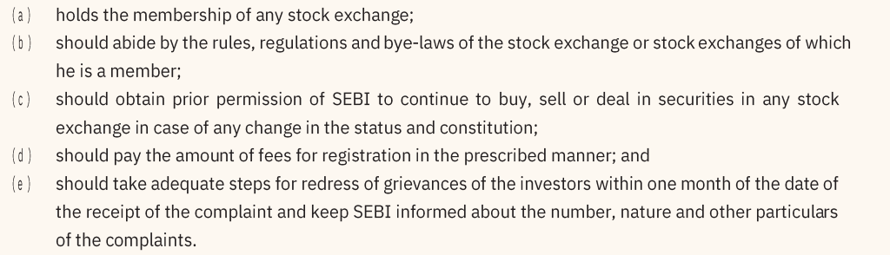 | 3
Q 18 | 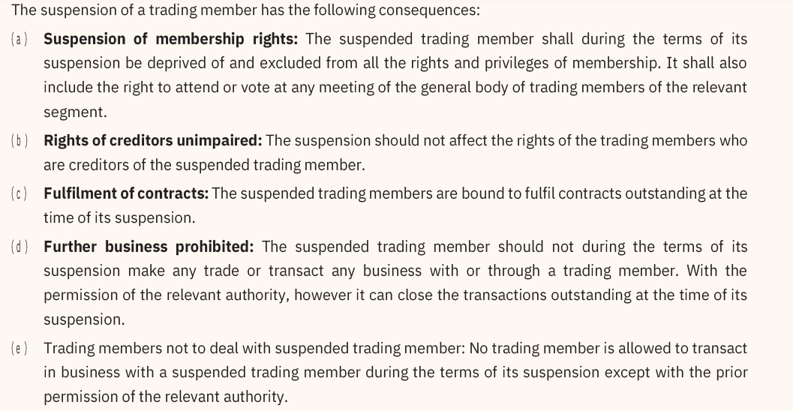 | 3
Q 19 |  | 3
 | Answer any 3 out of the given 5 questions in 50– 80 words each (4 x 3 = 12 marks)
Q. 20 | 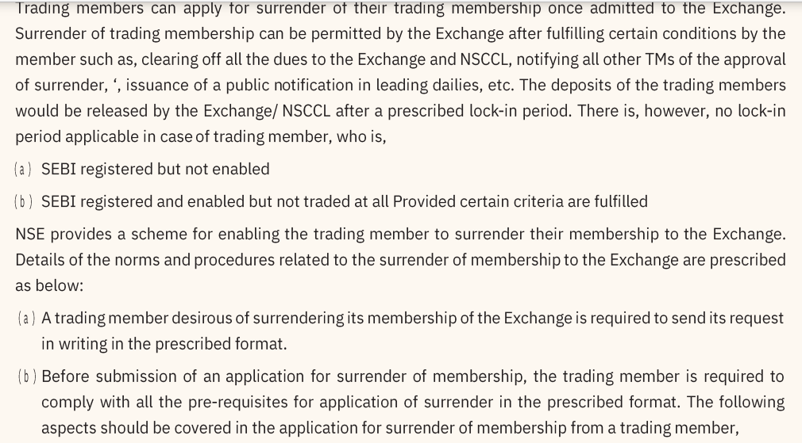 | 4
Q. 21 | - An order book is an electronic list of buy and sell for a specific security or financial instrument, organized by price level.  - An order book is dynamic and continuously updated in real time throughout the day.  - There are different types of order books based on the types of orders.  1) Pre-open book  - An order during the pre-open session is called pre-open order.  - Orders in pre-open session are stacked in book called pre-open book in order entry screen.  - At the end of the pre-open phase, the matching of pre-open orders takes place at the final opening price.  2) Regular lot book  - An order that has no special condition associated with it is a regular lot order.  - Computer matches regular lot orders with the passive orders in the system. If it does not find a match, it gets stacked in the Regular Lot book as a passive order.  - Buyback orders are placed through the Regular Lot (RL) book.  3) Limit Order Book  - Limit orders are orders to buy or sell shares at stated quantity and stated price.  - If the price quantity conditions do not match, the limit order will not be executed.  - Limit order book’ also known as ‘open book’ refers to the fact that only the limit orders are stored in the book and all market orders are crossed against the limit order present in the book.  4) Special Term Book  - Orders with special term attributes attached to it are knows as ‘special term orders’.  - Currently this facility is not available in the trading system but it will be introduced soon.  - A special term order entered in system scans Regular Lot book as well as special term books for matching to find the match  5) Stop loss book  - Stop loss orders are very popular due to their use in risk management. They get executed only when market prices surpass the trigger price. Till then they are stacked in Stop-Loss book.  - The SL order is either a market order or a limit price order.  6) Odd lot book  - The Odd lot book can be selected, by selecting the book type OL, to trade in the Odd Lot Market.  - Lot size is normally 100 shares. Below 100 shares the lot becomes odd lot.  - Order matching in this market takes place between two orders on the basis of quantity and price.  7) RETDEBT Order Book  - RETDEBT market orders can be entered into the system by selecting RETBEDT order book denoted as ‘D’.  - These orders scan only the RETDEBT Order Book for potential matches.  - If no suitable match found, it remains as passive order.  8) Auction Price Book  - A trading members who participates in the exchange initiated auction places orders in Auction Price book.  - Auctions orders can be initiator orders, competitor orders and solicitor orders. | 4
Q. 22 | - incorporate a company in GIFT SEZ.  - Submit application to GIFT SEZ-IFSC & obtain approval from Development Commissioner.  - Submission of application to NSE IFSC / NSE IFSC CC.  - Grant of NSE IFSC Exchange/CC offer letter subject to SEBI Approval.  - Onward submission by NSE IFSC to SEBI for registration. | 4
Q. 23 | Pre-open market session : Pre-open session was introduced to minimise the volatility and to discover the opening process of securities during the market opening every day and is only allowed for the equity segment. It is conducted between 9:00 AM to 9:15 AM on NSE and BSE. | 4
Q. 24 | This function is used to enable the User to view the outstanding orders (buy/sell) for a selected security. An outstanding order is an order that has been entered by the user, but which has not yet been completely traded or cancelled. The User is permitted to see his own/client’s orders and can modify/cancel the orders till it gets executed. All the figures are till the time of invoking the window.  The Snap Quote is a feature available in the system to get instantaneous market information on a desired security. This is normally used for a security that is not setup in the Market Watch window. The information displayed is same as that in Market Watch window i.e. Corporate action indicator "Ex/Cum", the total buy order quantity, best buy price, best sell price, total sell order quantity, last traded price, last trade price change indicator and the no delivery indicator "ND". The information can be viewed without disturbing the market watch.  The Activity Log (AL) shows all the activities which have been performed on any order belonging to that User. These activities include order modification / cancellation, partial / full trade, trade modification / cancellation. It displays information of only those orders in which some activity has taken place. It does not display those orders on which no activity has taken place. All the figures are till the time of invoking the window. | 4
 | ***

